Critical Incident Paper
Federal Trade Commission and European Commission settled suit against Intel (2009)
Mariia Lukashenko
ECO-414
Dr. Baranes
December 10, 2025

Introduction
The critical incident in this paper is the coordinated antitrust action against Intel by the European Commission (2009) and the U.S. Federal Trade Commission (2010). Regulators argued that Intel - the dominant supplier of x86 central processing units (CPUs) - did not just compete aggressively. They claimed Intel used its market power for years to block rivals from reaching customers, especially AMD (European Commission, 2009; Federal Trade Commission, 2010). The main tools were not technical advantages, but contracts and payments: Intel allegedly offered large “conditional rebates” to major computer makers, meaning the discounts depended on buying all, or almost all, CPUs from Intel, and regulators also described “naked restrictions” - direct payments that were tied to delaying, cancelling, or limiting computers that used AMD chips (European Commission, 2023). Because of that, this paper treats the Intel case as a microeconomic example of monopoly maintenance through exclusionary contracting. My claim is that Intel’s rebate structure and conditional payments worked like strategic foreclosure, and the central discussion is how these rebate schemes were working from an economic perspective.
The roots of this critical incident go back to long-running rivalry between Intel and AMD. Complaints about Intel’s contracting practices emerged in the 1990s, but the modern wave began when AMD filed a formal antitrust complaint with the European Commission in 2000 (European Commission, 2009, Section II, para. 5). The EC opened an in-depth investigation in 2004 into Intel’s rebate and pricing schemes with OEMs and retailers (European Commission, 2009, Section II, para. 7). On 13 May 2009, the EC issued its landmark decision finding that Intel had abused its dominant position in the x86 CPU market through conditional rebates to major OEMs and a large retailer and through “naked restrictions” whereby Intel paid OEMs to delay, cancel, or restrict AMD-based product launches, ordered Intel to cease these practices, and levied the €1.06 billion fine (European Commission, 2009, Section IX, para. 1789). At the same time, U.S. authorities also escalated their response: on 16 December 2009, the FTC filed an administrative complaint against Intel under Section 5 of the FTC Act, and in August 2010, Intel and the FTC reached a consent settlement in which Intel agreed to stop conditioning benefits on exclusivity, to avoid certain forms of bundling and retaliation, and to change how it handled intellectual property to ensure that rival chip designers could interoperate with Intel’s CPUs (Federal Trade Commission, 2010).
At the time of the European Commission’s 2009 decision, Intel’s dominance in the x86 CPU market was striking. The General Court described Intel as holding “roughly 70 percent or more” of the global CPU market between 2002 and 2007 (General Court, 2014). The EC imposed a record fine of €1.06 billion on Intel in May 2009 for abuse of a dominant position in the x86 CPU market (European Commission, 2009, Section IX, para. 1789). Coverage of the decision emphasized both the size of the fine and the findings on conditional rebates and related restrictions.
The Intel conduct did not occur in isolation: earlier, the Korea Fair Trade Commission fined Intel US$25.4 million for anticompetitive rebates to Samsung to restrict AMD’s processors (Compass Lexecon, 2008), while the Japan Fair Trade Commission had also found unlawful rebate practices (Lohr, 2005). In the U.S., the FTC’s 2010 settlement, although it did not impose a monetary fine, required a detailed consent order that constrained Intel’s use of loyalty discounts, bundling and threats in both CPU and graphics markets, aiming to restore competitive conditions going forward (Federal Trade Commission, 2010).
From a microeconomic perspective, the key issue is not the mere existence of a large firm, but whether a dominant firm used mechanisms that foreclosed an equally capable rival and protected monopoly power over time (Geradin, nd.). When conditional rebates and “naked restrictions” make it risky or unprofitable for major OEMs to work with AMD, AMD’s expected volume becomes smaller and more volatile, weakening its scale and cash flow (Robertson, 2018). With tighter constraints on scale, AMD may face limits on R&D and pricing even if its technology is comparable (Goettler & Gordon, 2011). Over time, foreclosure can soften competitive pressure on Intel, allowing higher prices, slower innovation, and less product variety for consumers (Lauer, 2024; Zelger, 2020).

Critical Incident Overview
This critical incident shows how Intel used conditional rebates and targeted payments to choke off AMD’s access to key OEMs, raise barriers to scale, and weaken the only serious competitive constraint it faced. In microeconomic terms, Intel expanded its residual demand, increased its markups, and pushed the x86 CPU market toward an inefficient monopoly outcome: higher prices, lower output, and slower innovation. Even though the EC fine was later overturned, the economic logic is unchanged—exclusionary contracts in a duopoly can entrench dominance and pull an industry away from competitive performance. This makes the Intel case a clean setting for asking how imperfect competition, reduced demand elasticity, and strategic use of rebates jointly shape welfare and inform antitrust evaluation.

Learning Objectives
By the end of this critical incident, readers should be able to:
- Understand how Intel’s behavior in a duopolistic, price-leadership market led to outcomes less efficient than the competitive benchmark, and why such inefficiencies matter for antitrust assessment.
- Explain how Intel’s rebate and exclusivity practices reduced the elasticity of demand for Intel CPUs, thereby increasing its pricing power.
- Analyze why Intel preferred conditional rebates over standard competition and identify the payoff conditions under which such rebates are a profit-maximizing strategy for deterring AMD or other entrants.

Questions –
- Why does the Intel case (2009) demonstrate how imperfect competition in a duopolistic, price-leadership market can produce outcomes that are less efficient than the competitive benchmark—and why is that crucial for antitrust evaluation?
Define:
- Imperfect competition: A market setting where at least one firm has enough market power to influence price or output, so price is not driven down to marginal cost as in perfect competition.
- Duopoly: A market with two main suppliers. Strategic interaction matters because each firm’s pricing, output, and contracting choices affect the other’s profits and incentives.
- Price leadership: A duopoly pattern where one firm effectively sets the market price (or the price umbrella) and the rival responds, rather than both acting as price-takers.
- Lerner relationship (markup index): A link between market power and markup, often summarized as (p−MC)/p; less elastic demand typically supports a higher sustainable markup.
Discuss:
The x86 CPU market in the Intel case is best seen as an imperfectly competitive duopoly rather than a competitive industry. For most of the relevant period, Intel and AMD were essentially the only meaningful x86 suppliers, with Intel holding a dominant share and entry constrained by massive sunk R&D, fabrication costs, and IP. This makes the “many small price-taking firms” benchmark unrealistic. Under imperfect competition a dominant firm has market power: instead of taking price as given, it chooses price and output to maximize profit, as in the monopoly benchmark where ym < yc and pm​ > pc​. That outcome is Pareto-inefficient because price stands above marginal cost and output is restricted relative to the competitive allocation. The Intel case matters because exclusionary conduct can push a real-world duopoly closer to this monopoly-style outcome even when a rival technically survives.
In a duopolistic, price-leadership setting Intel effectively acts as a dominant firm facing a residual demand curve. Figure below captures this: total market demand is given, AMD’s supply is subtracted out, and Intel chooses its output where residual marginal revenue equals its marginal cost. The resulting price p∗ already lies above marginal cost and implies lower total output than under perfect competition. Conditional rebates and exclusivity payments then shift this residual demand further in Intel’s favor. If rebates are conditioned on OEMs buying all or almost all of their CPUs from Intel, or if payments make AMD-based launches unprofitable, AMD’s effective supply to the market shrinks. In the dominant-firm diagram that looks like a leftward shift of the follower’s supply and an outward, less elastic residual demand for Intel. With a less elastic residual demand curve, the Lerner relationship implies that Intel can sustain a higher markup (p−MC)/p, reinforcing the distortion between price and marginal cost.
These practices also erode AMD’s ability to constrain Intel dynamically. By foreclosing key OEM and retail channels, Intel reduces AMD’s scale, raises its average costs given high fixed and sunk expenditures, and weakens its capacity to exert pricing pressure and finance innovation in future product cycles. Static welfare falls because Intel’s higher markups and restricted AMD access generate deadweight loss and reduce consumer surplus, both through higher prices and through reduced variety and delayed AMD-based products (Goettler & Gordon, 2011). Dynamic efficiency may also suffer if weaker rivalry dampens incentives to invest in performance improvements and cost-reducing innovation. In other words, Intel is not just exploiting existing market power; it is strategically reshaping the competitive constraint so that the duopoly behaves more like a monopolized market on a large part of demand.
This is crucial for antitrust evaluation because the legal assessment depends on which microeconomic model we use as the baseline. If one starts from a naive competitive benchmark, conditional rebates look like aggressive price competition that should be welcomed. But once we recognize that the x86 market is a dominant-firm duopoly, the same rebates and exclusivity payments can be understood as tools for foreclosure: they reduce the contestable share of demand and weaken an as-efficient rival, allowing the dominant firm to maintain monopoly-like prices and profits. That is exactly why competition authorities and courts focus on concepts like residual demand, markups, and as-efficient-competitor tests in cases like Intel. The imperfect-competition framework is not a cosmetic choice - it is what reveals the welfare loss relative to a competitive benchmark and justifies intervention. Therefore, because Intel’s conduct increased market power, sustained prices above marginal cost, and restricted output (and potentially innovation) relative to the competitive benchmark, the resulting outcome is unambiguously less efficient than under competition.
Diagram:
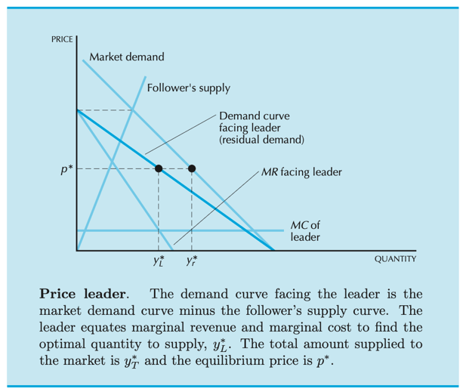

- Why did Intel’s rebate and exclusivity practices make demand for Intel CPUs less elastic, and how did that increase Intel’s pricing power?
Define:
- Price elasticity of demand (ε): How responsive quantity demanded is to a change in price; ∣ε∣ is the absolute value that measures sensitivity.
- Markup rule: The relationship from profit maximization MR=MC showing that lower ∣ε∣ implies a higher optimal price–cost margin.
- Conditional (loyalty) rebate: a discount contingent on meeting a purchase-share threshold
Discuss:
Chapter 25 Varian and Melitz (2024) clearly shows market power is linked directly to the price elasticity of demand. For a firm facing a downward‑sloping demand curve, marginal revenue is
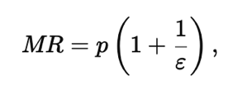
where ε is the price elasticity of demand. Setting MR=MC and solving for the optimal price gives the markup rule:
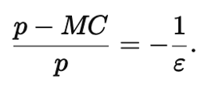
Because ε < 0, the right-hand side is positive. The absolute value ∣ε∣ measures how sensitive quantity demanded is to price. If ∣ε∣ is large (very elastic demand), then −1/ε is small and the optimal markup over marginal cost is low. If ∣ε∣ is small (inelastic demand), −1/ε is large and the optimal markup is high. So if a firm can make the demand it faces less elastic, it can profitably keep price further above marginal cost while still satisfying MR=MC.
Intel’s rebate and exclusivity practices can be understood as a deliberate attempt to engineer exactly this kind of less elastic demand from its most important customers - large PC manufacturers (OEMs) and big retailers. In a simple world with no such contracts, an OEM compares Intel and AMD just by looking at their prices and performance. If Intel raises its price a bit, some OEMs will shift part of their orders to AMD. That means the quantity Intel sells responds quite sensitively to price differences: the demand Intel faces is relatively elastic.
Conditional rebates tied to exclusivity change the decision problem for the OEM. Intel’s payments were often structured so that the OEM received a large rebate on all its Intel purchases only if Intel’s share of the OEM’s CPU purchases stayed above some very high threshold. That makes AMD a much weaker outside option. When an OEM considers buying some AMD chips, it is no longer just “Intel price vs. AMD price.” It is “AMD price plus the loss of Intel’s rebate on the whole Intel volume” versus “Intel price with the rebate preserved.” Losing that rebate can be worth far more than the savings from switching a small share of systems to AMD.
Economically, these contracts raise switching costs. The “marginal” unit the OEM diverts to AMD causes a loss of rebate on all the inframarginal Intel units. From the OEM’s point of view, the effective cost of moving even a small amount of business to AMD is huge, so a modest price increase by Intel will not induce much switching. Quantity demanded becomes much less responsive to price; ∣ε∣ falls. In micro terms, AMD stops being a close, effective substitute for Intel for those OEMs locked into rebate schemes, so Intel’s residual demand curve (the demand it faces after rivals’ behavior is taken into account) becomes steeper. By making demand less elastic through rebates and exclusivity, Intel shifts itself into a situation where the markup condition allows a higher price–cost margin.
On the graph, this corresponds to the blue curve MC/(1−1/∣ε∣) moving up and intersecting demand at a higher price p∗. Intel does not need to cut prices aggressively to keep OEMs; the penalty for switching (losing the rebate) keeps them in line. That is why the competition authorities cared so much about the structure of the rebates: they are not just discounts, they are a mechanism for reducing the elasticity of demand that Intel faces, and therefore for protecting and enhancing Intel’s monopoly markups.
Diagram:
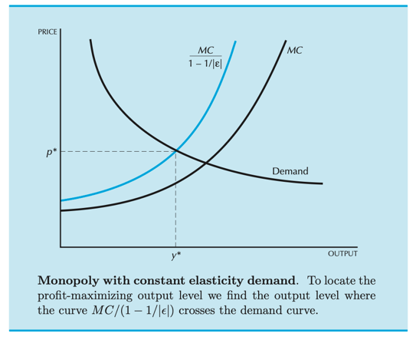
The downward sloping curve is demand; the upward sloping black curve is marginal cost MC. The blue curve is MC/(1−1/∣ε∣). This blue curve is just the marginal cost curve “inflated” by the markup term implied by the elasticity. Profit is maximized where the blue curve crosses the demand curve; that gives the optimal quantity y∗ and corresponding price p∗. When demand becomes less elastic (|ε| falls), 1/∣ε∣ gets larger, the denominator 1−1/∣ε∣ gets smaller, and the whole blue curve MC/(1−1/∣ε∣) moves upward. Its intersection with demand occurs at a higher price and a lower quantity. Graphically, making demand less elastic literally raises the markup curve and delivers more pricing power.

- Why did Intel choose to implement conditional rebates rather than compete without them, and under what payoff conditions is using rebates the profit‑maximizing strategy for deterring AMD or other entrants?

Define:
- Incumbent (dominant firm): the established market leader with scale and entrenched access to buyers (Intel).
- Entrant/expander (rival): the competitor deciding whether to expand output/capacity and pursue major customers (AMD).
- Monopoly maintenance: actions aimed at preserving monopoly-like outcomes by keeping the rival small or out.
- Conditional (loyalty) rebate: a discount contingent on meeting a purchase-share threshold (e.g., “all or almost all” from Intel).
Discuss:
A useful way to interpret the Intel case is as a problem of monopoly maintenance by a dominant incumbent facing a single meaningful rival. In the 2000s Intel held a very large share of the x86 CPU market, while AMD was widely viewed as an “as-efficient” competitor on the technology side but much weaker on scale and access to OEMs. The European Commission and the FTC argued that Intel did not merely compete on price and quality but used conditional rebates and direct payments to key OEMs and a major retailer to reshape the strategic environment AMD faced. Microeconomically, these practices can be framed as a deliberate attempt to change AMD’s best response from “enter and expand” to “stay small or stay out,” thereby preserving Intel’s market power.
Game theory makes this logic precise. Consider a simple sequential game with two players: Intel as the incumbent and AMD as the potential entrant/expander. In the first stage, Intel chooses a contracting policy with OEMs: either it offers loyalty rebates conditioned on purchasing all or almost all CPUs from Intel (strategy R), or it refrains from such rebates and competes on more standard terms (strategy N). In the second stage, after observing Intel’s choice, AMD chooses whether to enter aggressively (invest in capacity, marketing, and design wins with OEMs, strategy E) or to scale back / stay out (strategy S). The four terminal outcomes (R,E),(R,S),(N,E),(N,S) correspond to different profit levels for each firm.
Let $P_{m}$ denote Intel’s monopoly profit when AMD does not enter at scale, and $P_{d}$ denote Intel’s profit in a duopoly if AMD does enter and gains significant OEM business. Offering large conditional rebates involves a cost C to Intel: these payments reduce Intel’s per-unit margin and represent a transfer to OEMs. If Intel chooses no rebate (N), AMD typically expects positive profit from entry, because OEMs are free to allocate CPU purchases based on relative price–performance and AMD can obtain meaningful volume. In that branch of the game AMD’s best response is E, and Intel’s payoff collapses from $P_{m}$ to $P_{d}$.
By contrast, if Intel commits to strong conditional rebates (R), the payoff structure changes. OEMs that shift a substantial share of purchases to AMD risk losing sizeable rebates on their remaining Intel volume. That effectively raises AMD’s “entry cost”: to win the same design wins, AMD must compensate OEMs for foregone rebates through deeper discounts or accept much smaller volumes. In expected-payoff terms, AMD’s profit from aggressive entry falls, potentially below zero. In the game-theoretic language, Intel’s choice of R is designed so that AMD’s best response switches from E to S. Intel then earns $P_{m}$ − C instead of $P_{d}$. As long as
$P_{m}$− C > $P_{d}$,
rebates are a profit-maximizing entry-deterrence strategy: Intel willingly gives up C in short-run profit to avoid the much larger loss associated with sharing the market.
This framework maps closely onto the factual allegations in the Intel case. Conditional rebates granted to OEMs such as Dell, HP, Lenovo, Acer, and to a major retailer were allegedly structured so that OEMs would face a substantial penalty if they awarded significant CPU business to AMD. Payments characterized as “naked restrictions” further compensated OEMs for delaying or cancelling AMD-based product lines. In the model below, these mechanisms are precisely what makes the rebate strategy R credible and effective: they reduce the expected payoff to AMD from choosing E and thereby alter the equilibrium path of the game in Intel’s favor. Rather than a symmetric duopoly with two firms freely competing for OEM slots, the market behaves more like a dominant-firm model in which the follower is kept below efficient scale.
From a welfare perspective, the game-theoretic analysis reinforces the standard monopoly story from microeconomics. When Intel succeeds in deterring or marginalizing an as-efficient rival, the market outcome moves closer to the monopoly benchmark: higher prices relative to marginal cost, lower effective output and variety, and a deadweight loss relative to a competitive or duopolistic structure. The core insight is that conditional rebates are not merely discounts; in a dynamic setting with a dominant firm and a single close rival, they can function as a strategic investment in preserving monopoly power by manipulating the rival’s incentives and constraining the feasible equilibrium paths of the game.
Diagram:
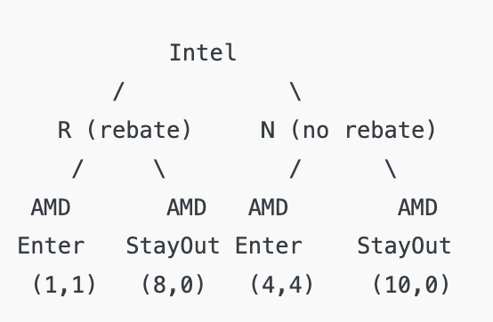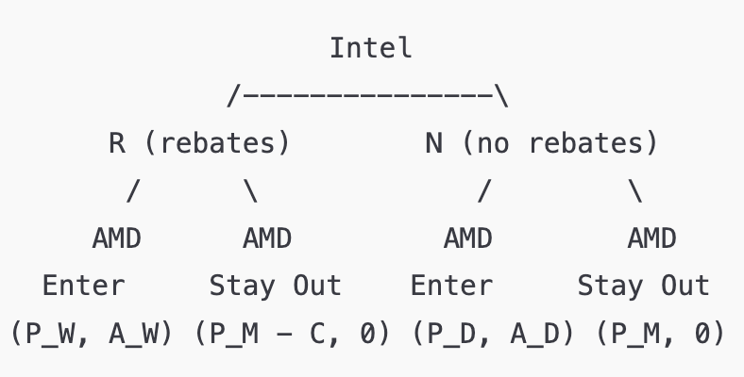

Epilogue
The Intel incident shows that market power in high-tech markets can be preserved not only through superior products, but through strategic contracting that reshapes competition. The core issue was not Intel’s processor quality, but whether conditional rebates and exclusivity payments limited AMD’s ability to reach customers and scale on equal terms (European Commission, 2009; Dentons, 2017). By controlling access to key distribution channels, a dominant firm can shrink rivals’ scale, weaken innovation incentives, and raise long-run prices—concerns that remain central as the chip industry moves into an era of AI accelerators, advanced CPUs, and tightly integrated platforms (Lauer, 2024).

After a long litigation path, Intel ultimately avoided paying the European Commission’s €1.06 billion fine when the decision was overturned in 2024 (Court of Justice of the European Union, 2024). This outcome turned mainly on evidentiary standards: Intel attacked the Commission’s economic analysis, especially the as-efficient-competitor test, arguing that foreclosure had not been proven to the required legal standard (Skadden, Arps, Slate, Meagher & Flom LLP, 2022; Lauer, 2024).

References
- Court of Justice of the European Union. (2024, October). Case C-240/22. EUR-Lex. https://eur-lex.europa.eu/legal-content/EN/TXT/?uri=CELEX:62022CJ0240
- European Commission. (2023). Questions and answers - Commission re-imposes €376.36 million fine on Intel for anticompetitive practices in the market for computer chips. European Commission. https://ec.europa.eu/commission/presscorner/detail/en/qanda_23_4571
- European Commission. (2009). Case 37990: Intel. Commission Decision. https://ec.europa.eu/competition/antitrust/cases/dec_docs/37990/37990_3581_18.pdf
- Compass Lexecon. (2008). Korean Fair Trade Commission v. Intel [Case summary]. https://www.compasslexecon.com/cases/korean-fair-trade-commission-v-intel
- Lohr, S. (2005, March 9). Japan says Intel violated antimonopoly law. The New York Times. https://www.nytimes.com/2005/03/09/technology/japan-says-intel-violated-antimonopoly-law.html
- Varian, H. R., & Melitz, M. J. (2024). Intermediate microeconomics with calculus: A modern approach (2nd ed.). W. W. Norton & Company.
- Court of Justice of the European Union. (2024, October 24). The Court of Justice upholds the annulment by the General Court of the Commission decision imposing a fine on Intel (Press Release No. 185/24). CURIA. https://curia.europa.eu/jcms/upload/docs/application/pdf/2024-10/cp240185en.pdf
- European Commission. (2009, May 13). Antitrust: Commission imposes €1.06 billion fine on Intel for abuse of dominant position; orders Intel to cease illegal practices (IP/09/745). https://ec.europa.eu/commission/presscorner/detail/en/ip_09_745
- Wikipedia. (n.d.). Advanced Micro Devices, Inc. v. Intel Corp. Wikipedia. https://en.wikipedia.org/wiki/Advanced_Micro_Devices%2C_Inc._v._Intel_Corp.
- Singer, M. (2005, June 28). Intel and AMD: A long history in court. CNET News. https://web.archive.org/web/20121105132430/http://news.cnet.com/Intel-and-AMD-A-long-history-in-court/2100-1014_3-5767146.html
- Federal Trade Commission. (2010, August 4). FTC settles charges of anticompetitive conduct against Intel. https://www.ftc.gov/news-events/news/press-releases/2010/08/ftc-settles-charges-anticompetitive-conduct-against-intel
- Federal Trade Commission. (2010, November). Intel Corporation, a matter (Docket No. 9341; File No. 061-0247). https://www.ftc.gov/legal-library/browse/cases-proceedings/061-0247-intel-corporation-matter
- Skadden, Arps, Slate, Meagher & Flom LLP. (2022, February). EU General Court overturns Intel antitrust fine. https://www.skadden.com/-/media/files/publications/2022/02/eu_general_court_overturns_intel_antitrust_fine.pdf
- General Court. (2014, June). Case T-286/09. EUR-Lex. https://eur-lex.europa.eu/legal-content/EN/TXT/?uri=CELEX:62009TJ0286
- Dentons. (2017, September 7). The Intel case. https://www.dentons.com/en/insights/alerts/2017/september/7/the-intel-case
- Geradin, D. (n.d.). The Decision of the Commission of 13 May 2009 in the Intel case: Where is the foreclosure and consumer harm?. Intel. https://www.intel.com/pressroom/legal/docs/Damian_paper.pdf
- Bates White Economic Consulting. (n.d.). AMD case study. https://www.bateswhite.com/media/publication/124_AMD%20case%20study.pdf
- (Peer-reviewed) Robertson, V. (2018, April). Rebates under EU Competition Law after the 2017 Intel Judgment: The Good, the Bad and the Ugly. Market And Competition Law Review, 15–18. Hein Online. https://heinonline.org/HOL/Page?collection=journals&handle=hein.journals/mclr2&id=18
- (Peer-reviewed). Venit, J. (2014). James S. Case T-286/09 Intel V Commission-The Judgment Of The General Court: All Steps Backward And No Steps Forward, European Journal of Competition. 203-230p. https://research.ebsco.com/c/k7hu7l/viewer/pdf/ejorhy2ikv?route=details
- (Peer-reviewed) Goettler, R & Gordon, B. (2011). Does AMD Spur Intel to Innovate More?. Journal of Political Economy, Volume 119, Number 6. https://doi.org/10.1086/664615
- (Peer-reviewed) Zelger, B. (2020). EU Competition law and extraterritorial jurisdiction a critical analysis of the ECJ's judgement in Intel. European Competition Journal. https://research.ebsco.com/c/k7hu7l/viewer/pdf/4vxf2ov7gb?route=details
- (Peer-reviewed) Geradin, D. (n.d.). Loyalty Rebates After Intel: Time For The European Court Of Justice To Overrule Hoffman-La Roche. Journal of Competition Law & Economics.
https://heinonline.org/HOL/Page?lname=&public=false&collection=journals&handle=hein.journals/jrcolaec11&men_hide=false&men_tab=toc&kind=&page=579
- (Peer-reviewed) Lauer, R. (2024). The Intel saga: what went wrong with the Commission's AEC test (in the General Court's view)?. European Competition Journal. https://research.ebsco.com/c/k7hu7l/viewer/pdf/r4ulttsl3j?route=details

